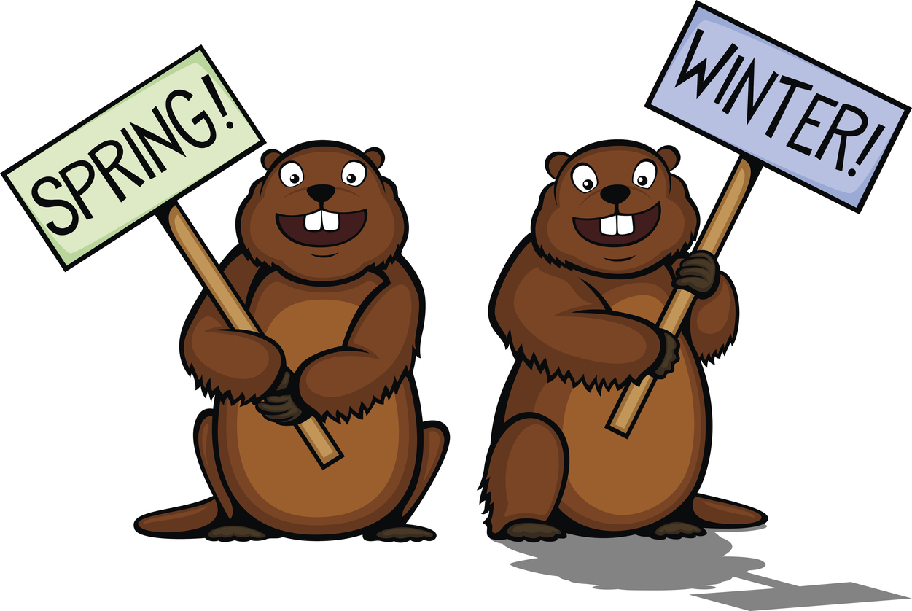
2019
Sun | Mon | Tue | Wed | Thu | Fri | Sat
 |  |  |  |  | 1 | Groundhog Day
3 | 4 | 5  Skating  Kindergarten | 6 | 7  Skating – Gr 1 | 8 | 9
10 | 11  STAFF APPRECIATION WEEK | 12  Skating – Gr. 2 | 13 | 14  Skating – Gr. 3  Valentine’s Day Special Meal  Bake Sale  Gr 4 Williston | 15  Flag Day  Wear Red & White | 16
17 | 18  Family Day  NO SCHOOL | 19  Skating – Gr. 4 | 20 | 21  Skating – Gr. 5 | 22 | 23
24  H&S meeting  @ 6:30pm | 25  Loose change Due  Black Light Show  JMH  Students Only | 26  Black Light Show  JMH @ 6:30pm  For Parents/Public  Admission:  Donation @ Door | 27  PINK Shirt Day | 28

