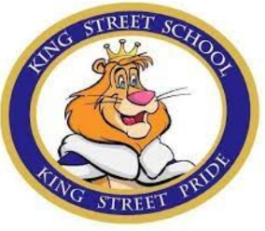
Grade 1 – English School Supplies
King Street Elementary
2021-2022

- 1 Colouring book
- 6 Elmer’s glue sticks
- 1 Elmer’s liquid white glue
- 1 pair of scissors
- 1 plastic pencil box
- 3 Boxes of Facial Tissue
- Indoor Running Shoes
- 1 box of large and small Ziploc bags
- Extra set of clothes to be kept at school for
emergencies (Please put in labeled Ziploc bag)
- 6 pkgs Crayola Crayons
- 1 pair of headphones labeled (not earbud style please)
- 5 dry erase markers fine tip
- 3 White erasers
- 1 Pkg HB Pencils
- 12 Duo-Tangs 2yellow,2red,2blue,
2green and 2orange, 2 purple
- Courier Bag with zipper (Dollarama)
- 2 Plastic Duo tangs with inside pockets

