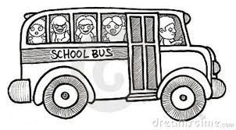
King Street Grade Two Immersion

Duotangs - 2 green, 2 red, 2 blue, 2 orange
1 Plastic duotang with pockets
Erasers (white only) 4 or 5
Pencils (2 pkg. of 12) – The blue Staedtler are the best
Glue sticks (6)
White glue
Scissors
Crayons (pack of 24)
Pencil Crayons (pack of 24)
Pencil Sharpener
4 highlighters
2 Writing Exercise Book – half lined, half plain
2 pkg of clear page protectors (can be found at the dollar store)
1-1 inch binder
1 pkg of dividers for binder
6 Dry erase markers (fine tip are best)
1 pkg Looseleaf
1 Pencil Box – hard plastic
Headphones (please write your child’s name on them)
Kleenex (4 boxes)
Ziploc bags (1 large box, 1 small box)
$5 for agenda and home folder to be purchased by teacher
*Please note that extra supplies may be required throughout the year.

