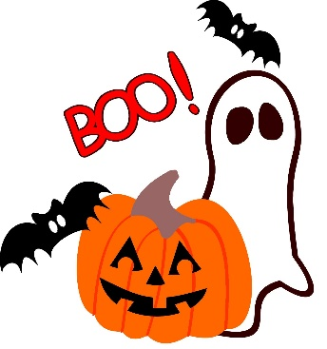
Memo
October 22, 2018

We will be celebrating Halloween on Friday, October 26th with a dance in the cafeteria. Therefore, lunch will be held at 11:25-12:25pm on this day only.
Dance
  - K-Gr.2 - 1:00 to 1:45pm
  - Gr.3-5 - 2:00 to 2:45pm

*Costumes are NOT to be worn to school. Students will change into their costume; independently, after lunch. Please No Props Please.

We will be treating October 31 as a regular day; No costumes, No treats.

Please do not feel as though you have to send Halloween treats. If you do, may we suggest healthy Halloween treats (orange slices, grapes, apples, yogurt tubes or cheese strings).

Memo
October 22, 2018

We will be celebrating Halloween on Friday, October 26th with a dance in the cafeteria. Therefore, lunch will be held at 11:25-12:25pm on this day only.
Dance
  - K-Gr.2 - 1:00 to 1:45pm
  - Gr.3-5 - 2:00 to 2:45pm

*Costumes are NOT to be worn to school. Students will change into their costume; independently, after lunch. Please No Props Please.

We will be treating October 31 as a regular day; No costumes, No treats.

Please do not feel as though you have to send Halloween treats. If you do, may we suggest healthy Halloween treats (orange slices, grapes, apples, yogurt tubes or cheese strings).

