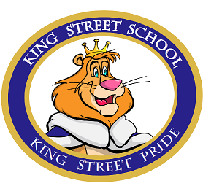Hi Lions! It’s Mrs. Hache and Ms. Petrie. First, let us say that we and all the teachers and EA’s and custodians and cafeteria staff at KSE have been thinking about all of you these past few weeks. This is a very different and sometimes-difficult situation we find ourselves in, however, we hope that by working together, we will get through it.
On Monday, you or an adult in your house can check our school website page http://kse.nbed.nb.ca/ , look for your teacher’s name and find some information about home learning opportunities.
Do you remember what we say every day at the end of the announcements? “Be kind to each other and listen to your teachers”. Now that you are learning at home, you have to be kind and listen to the adults at home. They are new to this too!
For our grade 5 students, rest assured that we are working with staff at Dr. Losier to make sure that we will be able to have some sort celebration of your time at King Street, whenever things get back to normal!
Finally, let’s give a Lion’s Roar to everyone who is doing their part to help us get through this, either as an essential worker, or by staying home and social distancing.

