Sun | Mon | Tue | Wed | Thu | Fri | Sat
 |  | 1 | 2 | 3 | 4 | 5  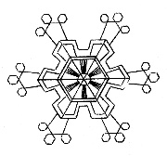
6 | 7 | 8 | 9 | 10 | 11 | 12
13 | 14 | 15  Skating  Kindergarten | 16 | 17  Skating – Gr. 1  ---  Gr 1 and Gr 6 French Immersion Entry Info Session - Gretna Green @ 6:30pm | 18 | 19
20 | 21 | 22  Skating  Grade 2 | 23  Parent Session for Kick off to K  @ 6:30 | 24  Skating  Grade 3 | 25  Gooey Gum Friday  Fundraiser – Bring your gum & $1 and chew all day!!!! | 26
27 | 28  NO School for Students | 29  Skating  Grade 4 | 30 | 31  Skating  Grade 5

