January Newsletter
King Street Elementary School

DATES TO REMEMBER
January 17 – Gr. 1 & Gr. 6 French Immersion Entry Info Session
at Gretna Green @ 6:30pm
January 23 – Parent Info Session for Kick off to K @ 6:30pm
January 28 – NO School for students– PD Day
February 18 – NO School – Family Day!!
February 27 – Pink Shirt Day
March 4-8 – March Break – NO School

Welcome To Sign

We are in the process of updating our Welcome To King Street sign in the Main Lobby. We are asking anyone that speaks anything other than English at home to please email Denise @ denise.kelly2@nbed.nb.ca the proper spelling of “Welcome To” in your language.
We are going to add it to the sign!!
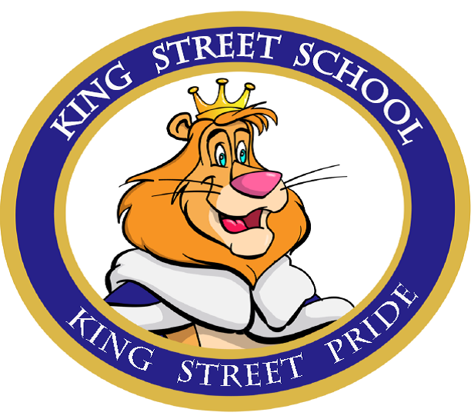

Public Skating Rules

The city of Miramichi has issued us with a few rules during the school usage of their ice surface at the LBA. Volunteers please be aware of the following:
- All participants must be wearing skates while on ice surface – NO Boots
- Absolutely No Food or Drinks permitted on the ice surface at any time.
- No Headsets, cell phones, or hand held electronics.

January Fundraiser
--------------------------
Gooey Gum Friday Fundraiser
Students can bring gum & $1 to donate and chew all day long!!

Skating Schedule
Jan. 15 – Kindergarten
Jan. 17 – Grade 1
Jan. 22 – Grade 2
Jan. 24 – Grade 3
Jan. 29 – Grade 4
Jan. 31 – Grade 5
Feb. 5 – Kindergarten
Feb. 7 – Grade 1
Students are reminded to dress appropriately. Helmets are Mandatory.

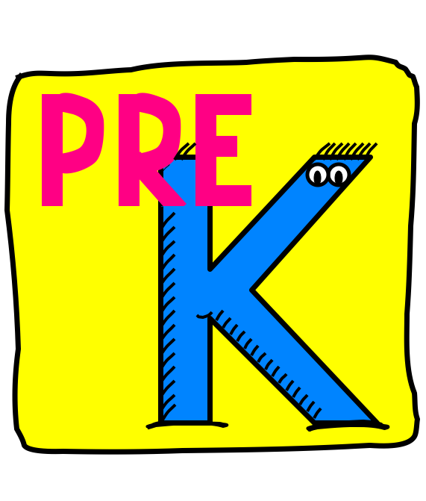
Kindergarten Info Session
Wednesday, January 23
For
Pre-Kindergarten Parents only
