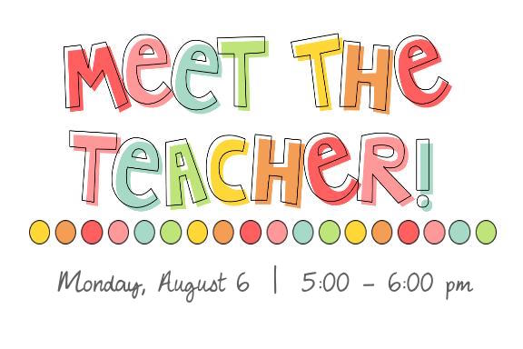
Wednesday, September 12 6:00 to 7:00pm
We will be having our Meet the Teacher this Wednesday the 12 at 6:00pm. Please note that this is not a parent teacher interview. It will be a night to meet your child’s teacher(s) and update families on our new playground, schedules, bussing, discipline, extra- curricular etc.
We will have our PSSC and Home & School elections @ 7pm.
Wednesday, September 12 6:00 to 7:00pm

We will be having our Meet the Teacher this Wednesday the 12 at 6:00pm. Please note that this is not a parent teacher interview. It will be a night to meet your child’s teacher(s) and update families on our new playground, schedules, bussing, discipline, extra- curricular etc.
We will have our PSSC and Home & School elections @ 7pm.
Wednesday, September 12 6:00 to 7:00pm

We will be having our Meet the Teacher this Wednesday the 12 at 6:00pm. Please note that this is not a parent teacher interview. It will be a night to meet your child’s teacher(s) and update families on our new playground, schedules, bussing, discipline, extra- curricular etc.
We will have our PSSC and Home & School elections @ 7pm.

