|  |
| --- |
| October |
| 2021 2021 |
| Millerton School – 4711 Route 108 Hwy, Derby, NB E1V5C3 Phone: 627-4090 |

|  |  |
| --- | --- |
| To get started right away, just click any placeholder text (such as this) and start typing to replace it with your own. Want to insert a picture from your files or add a shape? You got it! On the Insert tab of the ribbon, just tap the option you need. |  |

|  |  |  |  |  |  |  |
| --- | --- | --- | --- | --- | --- | --- |
| Sunday | Monday | Tuesday | Wednesday | Thursday | Friday | Saturday |
|  |  |  |  |  | 1 | 2 |
|  |  |  |  |  |  | Pumpkin Clip Art - Pumpkins Clipart - Moveable Images by Amy Harrison |
| 3 | 4 | 5 | 6 | 7 | 8 | 9 |
| **Fire Prevention**  **Week Oct 3 -9** |  |  | Thanksgiving Dinner  --  National  Walk to School Day!! |  |  |  |
| 10 | 11 | 12 | 13 | 14 | 15 | 16 |
| **Kindergarten Registration**  **Oct 12-22** | **NO SCHOOL**  **Thanksgiving Day** |  |  |  |  |  |
| 17 | 18 | 19 | 20 | 21 | 22 | 23 |
| Halloween clipart royalty free |  |  |  | **Skating**  Gr. 1 Gallant  Gr. 1 Scholfield/Hallihan |  | Pumpkin Clipart Apple - October Clip Art Black And White - Free Transparent  PNG Download - PNGkey |
| 24 | 25 | 26 | 27 | 28  **Skating**  Gr. 2 Gallant  Gr. 2 Russell | **29**  **Halloween Celebrations**  **In class bubbles** | 30 |
|  |  |  |  |  |  |  |
| 31 |  |  |  |  |  |  |
| Ghost Happy Halloween Clip Art Free PNG Image｜Illustoon |  |  |  |  |  |  |

**National Walk to School Day!!**

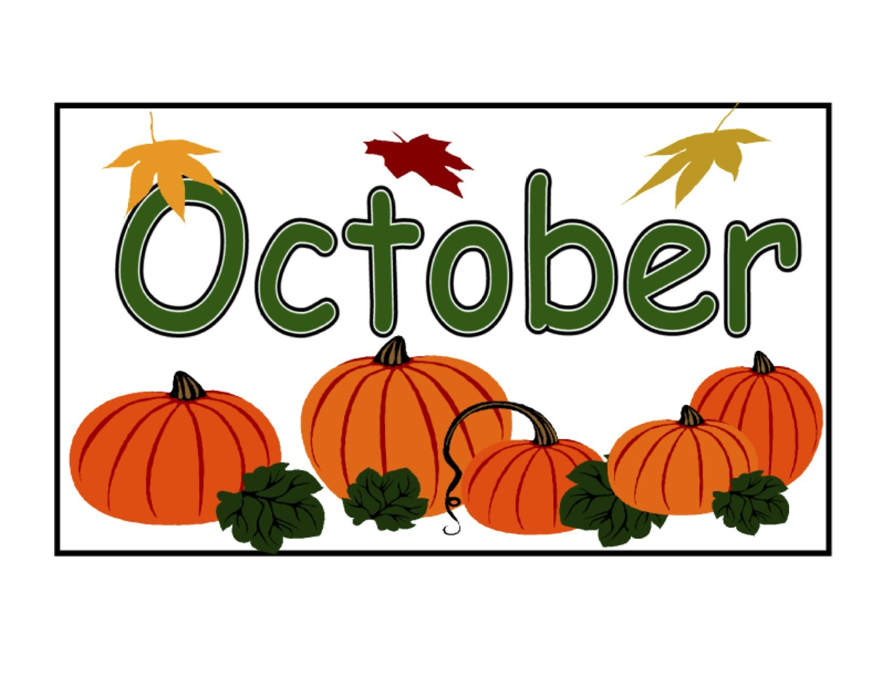

We encourage all our lions to walk, bike or roll to school as much as they can.

On **Oct. 6**, Mrs. Petrie will be at the corner of Wellington St and Princess St @ 8am, if anyone wants to walk to the school with her!!!

-----

*We would like to remind our school community that we are a* ***nut safe school****. "We have several students with nut allergies. Our school has been declared a* ***nut safe school****." This means that NO FOODS containing nuts should be brought into our school, including in individual student or staff lunches. We appreciate your cooperation in keeping our school community as safe as possible.*

-----

We also ask parents/guardians to Please continue to exercise caution in the Drop Off & Pick-Up Loop.

Please note if your child has two of the Covid-19 symptoms you are asked to keep them at home as directed by Public Health.

Public Skating Rules

The city of Miramichi has issued us with a few rules during the school usage of their ice surface at the LBA.

**Students** please be aware of the following:

* All students must wear a face mask while in the change room.
* No face mask needed on the ice surface.

**Volunteers** please email proof of vaccination to: [denise.kelly2@nbed.nb.ca](mailto:denise.kelly2@nbed.nb.ca)

Teachers will have a master list of the volunteers and if you are not on the list you will not have access to the rink. Volunteers are to wear a face mask at all times.

Students are reminded to dress appropriately. **Helmets are Mandatory.**

Why is showing Compassion Important?

Being compassionate towards others lets people know that they are not alone. It makes you a friend when someone needs a friend. It gives you a good feeling and helps you to understand other people and yourself. Compassion allows us to show other people that we understand and care.

What is Compassion?

Compassion means noticing when another person or animal is in need and showing concern for them.

Compassion is when you **SEE** someone in need, **CARE** about their feelings, and **DO** something to show you care.

What does Compassion look like?

Compassion begins by noticing when someone looks sad or troubled. Try putting yourself in their place and think about how you would feel if it were happening to you. Listen to the person, think about how you can help, and say kind things to them.

You are practicing Compassion when you …

* Notice that someone is hurt or needs a friend
* Listen to a classmate and try very hard to understand
* Forgive other people when they make mistakes
* Accept others without judging them or criticizing them
* Imagine how someone else is feeling
* Take time to show that you care
* Do something to help a person or an animal in need

Be kind whenever possible. It is always possible.

- Dalai Llama

King Street Elementary

September - October 2021