**KING STREET ELEMENTARY**

Newsletter – September 17

[](https://www.google.ca/url?sa=i&rct=j&q=&esrc=s&source=images&cd=&cad=rja&uact=8&ved=2ahUKEwjDn838-MHdAhUF9IMKHU1uAPQQjRx6BAgBEAU&url=https://www.sapulpaps.org/s_c_h_o_o_l_s/holmes_park_elementary/husky_news___announcements/spring_picture_day_&psig=AOvVaw1lUHCv8O0I4enoezKMfUKI&ust=1537270467360813)

[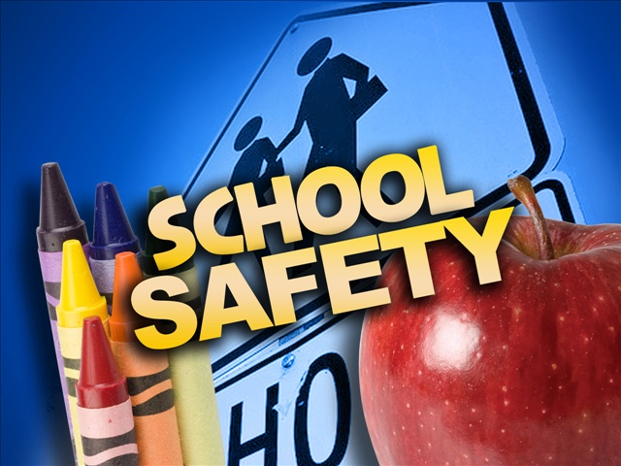](https://www.google.ca/url?sa=i&rct=j&q=&esrc=s&source=images&cd=&cad=rja&uact=8&ved=2ahUKEwicivyEgMLdAhVG3IMKHTa3Aq4QjRx6BAgBEAU&url=http://www.wtxl.com/news/thomasville-police-reminding-drivers-of-school-zone-safety/article_1f3926c8-7910-11e7-982e-4f7151a32a59.html&psig=AOvVaw2caM8DZePCWz7nPvUi-sBo&ust=1537272341589074)

KSE will practise a LOCKDOWN on Wednesday, Sept. 19

KING STREET

**Terry Fox run**

For cancer research

Students will be walking around the Turf @ 10:30 on Friday, Sept. 28. Parents/Guardians are welcomed to come and walk with their child. And, remember to bring a **toonie**!!

Please wear an orange shirt to support this cause & awareness.

[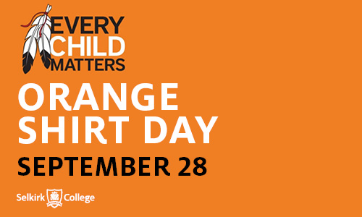](https://www.google.ca/url?sa=i&rct=j&q=&esrc=s&source=images&cd=&cad=rja&uact=8&ved=2ahUKEwjDhffOgcLdAhVJ9IMKHT3pCzwQjRx6BAgBEAU&url=http://selkirk.ca/event/orange-shirt-day-truth-and-reconciliation&psig=AOvVaw1BtwaCuM-sCr_06j7lzPCE&ust=1537272741985952)

Please bring your smile:

September 20 – Grade K-2

September 21 – Grade 3-5

**Sibling Pictures will be on Retake Day**

[](https://www.google.ca/url?sa=i&rct=j&q=&esrc=s&source=images&cd=&cad=rja&uact=8&ved=2ahUKEwjpja2rg8LdAhVk_4MKHaa6CKoQjRx6BAgBEAU&url=http://iqrafoundation.com/2014/08/welcome-back-to-school/&psig=AOvVaw0GAwjLuYK7i_ewDvcR0H1n&ust=1537273232181488)

Thank You!

We would like to take this opportunity to thank parents/guardians for you continued support on our new transportation protocols.