MEMO
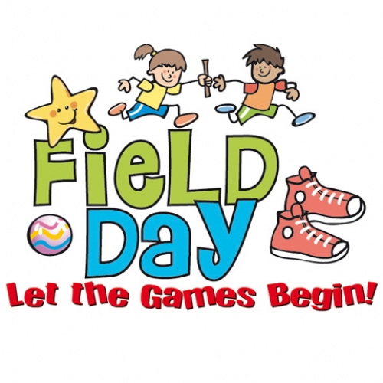
To: Parents/Guardians
From: Paula Hache, Principal
Date: May 28, 2018
Re: Volunteers for Track & Field Day

We are looking for parents/guardians to help our staff with the Grade 3, 4 & 5 Track & Field Meet @ JMH on Tuesday, June 19.

For those of you that would like to volunteer your time please insure that you have completed the Policy 701 questionnaire and submitted it to the school.
Here is the link if you do not have Policy 701 (http://701.nbed.nb.ca/toc-e.asp ). Please complete the questionnaire, print and return it to KSE.
Also, complete the form attached below and return to your child’s homeroom teacher by Thursday, May 31. You will be contacted with the time we would like you to come out and help.

Volunteer Name: ____________________________ Phone # _____________
How are you able to Volunteer? Morning _______ or Afternoon _________
Students Name: ____________________________ Homeroom: __________

